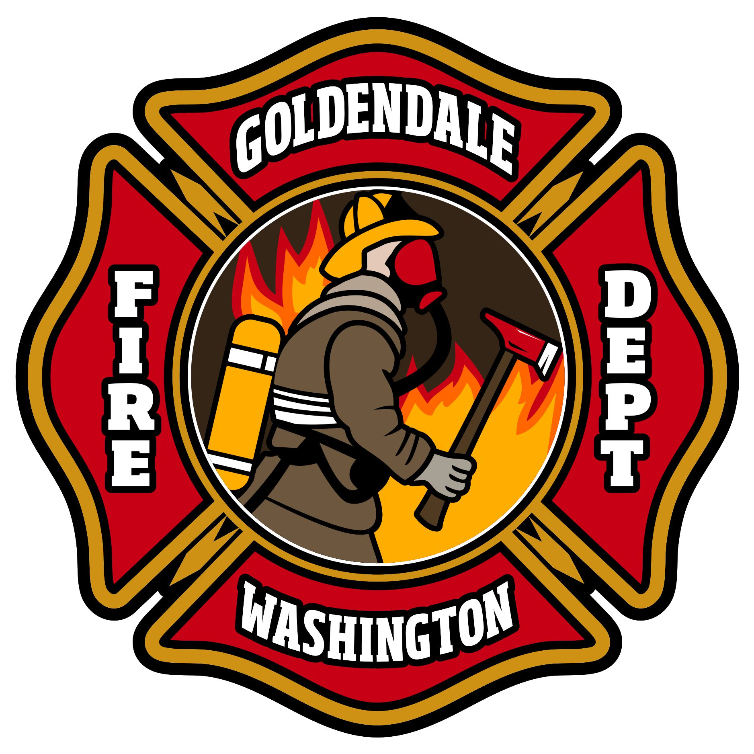
CITY OF GOLDENDALE
225 W. Court Street
Goldendale, WA 98620

FIRE DEPARTMENT
Phone 509-773-4240
Fax 509-773-4444
FDChief@ci.goldendale.wa.us
***Press Release***
Contact: Fire Chief, Noah Halm
509.773.4240
City of Goldendale Burn Ban 2026 Effective May 18, 2026.

Effective Monday, May 18, 2026, Chief Noah Halm is suspending all burn permits in the Goldendale City Limits, enacting the city-wide burn ban until further notice, in correlation with the Klickitat County Zone 2 Burn ban.

As we enter into the annual summer season, it is important to be fire-ready and Fire Wise. Create defensible space around your property and home. All residents are encouraged to visit the Klickitat County Emergency Management web page and sign up for Emergency Alerts, including fire evacuation notices.

For more information on defensible space and fire wise program visit https://www.dnr.wa.gov/firewise
To sign up for emergency alerts, visit the KCDEM website at https://www.smart911.com/smart911/ref/login.action?pa=klickitatco

